User’s View Analysis

# Use Case diagram:

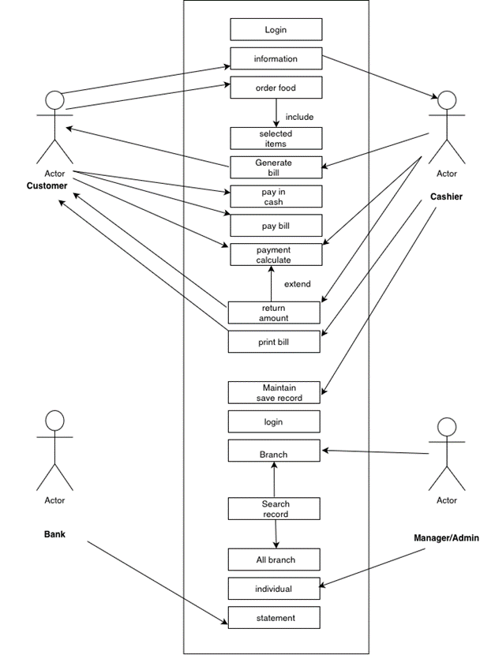

# Use-Case Scenario:

●      Admin gives access to cashiers to login.

●      Then the cashier enters the access code to access the system.

●      System enables secure communications.

●      System displays restaurant menu cards to the customer.

●      The Customer selects the items that are included in the menu and order-food.

●      Cashier generates a bill and collects the amount.

●      Amount Can either be collected through cash or online payment via phonepe, Paytm or card.

●      If Customer pays through cash, the cashier calculates the payment and returns the remaining amount if required.

●      Cashier prints the bill and the customer will collect the bill.

●      All the records are saved and maintained by the admin or cashier.

●      If the admin wants to search a particular amount, he can be done.

●      After billing, the transaction number is displayed by the system.